**TRAFFIC SIGN RECOGNITION USING DEEP LEARNING**

**ABSTRACT:**

Traffic sign recognition is crucial for autonomous driving and intelligent transportation systems. This paper presents a novel approach that combines the You Only Look Once (YOLO) framework with Region-based Convolutional Neural Networks (RCNN) to enhance the accuracy and efficiency of traffic sign detection and classification. YOLO serves as a real-time object detection model, capable of identifying multiple traffic signs in a single pass, while RCNN refines the detection by providing precise bounding box adjustments and improved classification.

Our method leverages the strengths of both architectures, employing YOLO for initial detection and RCNN for post-processing. The system is evaluated on a diverse dataset containing various traffic sign types under different environmental conditions. Results demonstrate significant improvements in detection accuracy and processing speed compared to traditional methods. Additionally, our approach shows robustness against occlusion and varying lighting conditions, making it suitable for real-world applications.

The integration of YOLO and RCNN not only enhances performance but also paves the way for more sophisticated traffic sign recognition systems that can be deployed in autonomous vehicles, thereby contributing to safer driving environments. Future work will focus on further optimizing the model and expanding the dataset for broader applicability.

**INTRODUCTION:**

Traffic sign recognition is a critical component of intelligent transportation systems and autonomous vehicles. As the demand for safer and more efficient roadways grows, the ability for machines to accurately identify and interpret traffic signs has become increasingly important. Traditional methods of traffic sign detection often rely on handcrafted features and simple classifiers, which can struggle with variability in lighting, weather conditions, and occlusions. In contrast, deep learning techniques have emerged as powerful tools for image recognition tasks, offering significant improvements in accuracy and robustness.

Deep learning models, particularly Convolutional Neural Networks (CNNs), have shown remarkable success in various computer vision applications, including object detection and classification. These models automatically learn hierarchical features from data, enabling them to generalize well across different scenarios. Recent advancements in architectures such as YOLO (You Only Look Once) and Faster R-CNN have further enhanced the capabilities of traffic sign recognition systems, allowing for real-time processing and high precision in detection.

This paper explores the application of deep learning techniques for traffic sign recognition, focusing on the integration of CNNs for feature extraction and classification. We analyze the performance of various architectures on a comprehensive dataset of traffic signs, emphasizing the importance of data diversity and augmentation in training robust models. Furthermore, we discuss the challenges associated with recognizing traffic signs in dynamic environments and propose strategies to overcome these obstacles.

By leveraging the strengths of deep learning, our work aims to contribute to the development of intelligent systems capable of improving road safety and enhancing the efficiency of transportation networks. The results presented herein demonstrate the potential of deep learning to revolutionize traffic sign recognition, paving the way for more reliable autonomous driving solutions.

**DIGITAL IMAGE PROCESSING**

The identification of objects in an image and this process would probably start with image processing techniques such as noise removal, followed by (low-level) feature extraction to locate lines, regions and possibly areas with certain textures.

The clever bit is to interpret collections of these shapes as single objects, e.g. cars on a road, boxes on a conveyor belt or cancerous cells on a microscope slide. One reason this is an AI problem is that an object can appear very different when viewed from different angles or under different lighting. Another problem is deciding what features belong to what object and which are background or shadows etc. The human visual system performs these tasks mostly unconsciously but a computer requires skilful programming and lots of processing power to approach human performance. Manipulation of data in the form of an image through several possible techniques. An image is usually interpreted as a two-dimensional array of brightness values, and is most familiarly represented by such patterns as those of a photographic print, slide, television screen, or movie screen. An image can be processed optically or digitally with a computer.

1. **Basics of Image Processing:-**

**FUNDAMENTALS OF DIGITAL IMAGE**

**1.1 IMAGE:**

An image is a two-dimensional picture, which has a similar appearance to some subject usually a physical object or a person.

Image is a two-dimensional, such as a photograph, screen display, and as well as a three-dimensional, such as a statue. They may be captured by optical devices—such as cameras, mirrors, lenses, telescopes, microscopes, etc. and natural objects and phenomena, such as the human eye or water surfaces.

The word image is also used in the broader sense of any two-dimensional figure such as a map, a graph, a pie chart, or an abstract painting. In this wider sense, images can also be rendered manually, such as by drawing, painting, carving, rendered automatically by printing or computer graphics technology, or developed by a combination of methods, especially in a pseudo-photograph.

 

**Fig: Colour image to Gray scale Conversion Process**

An image is a rectangular grid of pixels. It has a definite height and a definite width counted in pixels. Each pixel is square and has a fixed size on a given display. However different computer monitors may use different sized pixels. The pixels that constitute an image are ordered as a grid (columns and rows); each pixel consists of numbers representing magnitudes of brightness and color.

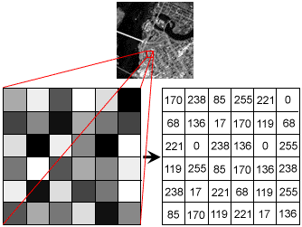

**Fig: Gray Scale Image Pixel Value Analysis**

Each pixel has a color. The color is a 32-bit integer. The first eight bits determine the redness of the pixel, the next eight bits the greenness, the next eight bits the blueness, and the remaining eight bits the transparency of the pixel.

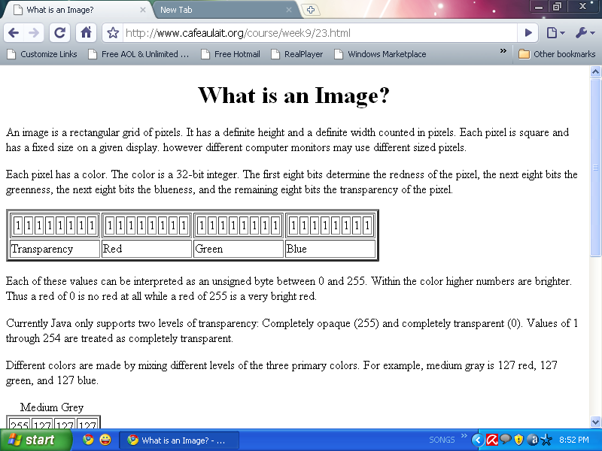

**Fig: BIT Transferred for Red, Green and Blue plane (24bit=8bit red;8-bit green;8bit blue)**

**IMAGE FILE SIZES:**

Image file size is expressed as the number of bytes that increases with the number of pixels composing an image, and the color depth of the pixels. The greater the number of rows and columns, the greater the image resolution, and the larger the file. Also, each pixel of an image increases in size when its color depth increases, an 8-bit pixel (1 byte) stores 256 colors, a 24-bit pixel (3 bytes) stores 16 million colors, the latter known as true color.Image compression uses algorithms to decrease the size of a file. High resolution cameras produce large image files, ranging from hundreds of kilobytes to megabytes, per the camera's resolution and the image-storage format capacity. High resolution digital cameras record 12 megapixel (1MP = 1,000,000 pixels / 1 million) images, or more, in true color. For example, an image recorded by a 12 MP camera; since each pixel uses 3 bytes to record true color, the uncompressed image would occupy 36,000,000 bytes of memory, a great amount of digital storage for one image, given that cameras must record and store many images to be practical. Faced with large file sizes, both within the camera and a storage disc, image file formats were developed to store such large images.

**IMAGE FILE FORMATS:**

Image file formats are standardized means of organizing and storing images. This entry is about digital image formats used to store photographic and other images. Image files are composed of either pixel or vector (geometric) data that are rasterized to pixels when displayed (with few exceptions) in a vector graphic display. Including proprietary types, there are hundreds of image file types. The PNG, JPEG, and GIF formats are most often used to display images on the Internet.

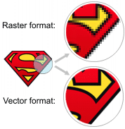

**Fig: Horizontal and Vertical Process**

In addition to straight image formats, Metafile formats are portable formats which can include both raster and vector information. The metafile format is an intermediate format. Most Windows applications open metafiles and then save them in their own native format.

**IMAGE PROCESSING:**

Digital image processing, the manipulation of images by computer, is relatively recent development in terms of man’s ancient fascination with visual stimuli. In its short history, it has been applied to practically every type of images with varying degree of success. The inherent subjective appeal of pictorial displays attracts perhaps a disproportionate amount of attention from the scientists and also from the layman. Digital image processing like other glamour fields, suffers from myths, mis-connect ions, mis-understandings and mis-information. It is vast umbrella under which fall diverse aspect of optics, electronics, mathematics, photography graphics and computer technology. It is truly multidisciplinary endeavor ploughed with imprecise jargon.

Several factor combine to indicate a lively future for digital image processing. A major factor is the declining cost of computer equipment. Several new technological trends promise to further promote digital image processing. These include parallel processing mode practical by low cost microprocessors, and the use of charge coupled devices (CCDs) for digitizing, storage during processing and display and large low cost of image storage arrays.

**FUNDAMENTAL STEPS IN DIGITAL IMAGE PROCESSING:**

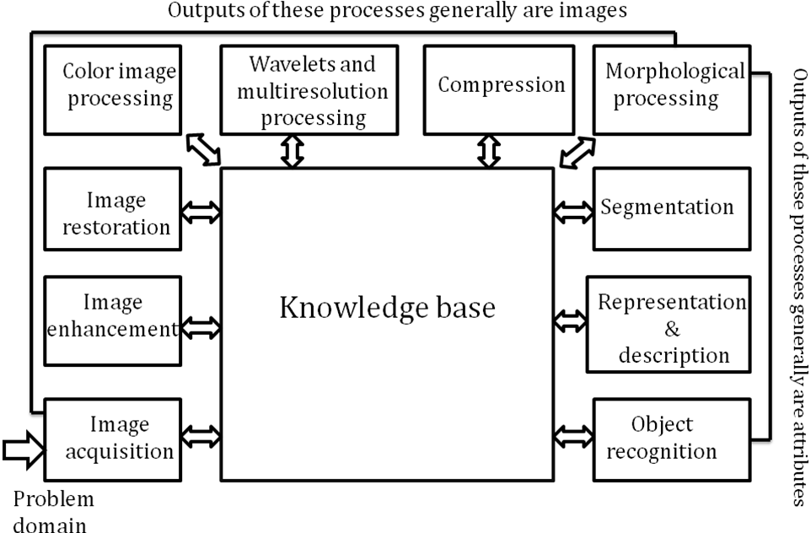**Fig: Basics steps of image Processing**

**Image Acquisition:**

**Image Acquisition** is to acquire a digital image. To do so requires an image sensor and the capability to digitize the signal produced by the sensor. The sensor could be monochrome or color TV camera that produces an entire image of the problem domain every 1/30 sec. the image sensor could also be line scan camera that produces a single image line at a time. In this case, the objects motion past the line.

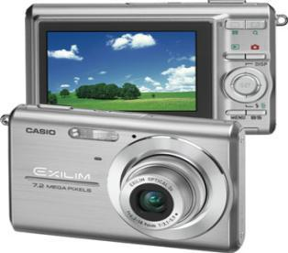

**Fig: Digital camera**

Scanner produces a two-dimensional image. If the output of the camera or other imaging sensor is not in digital form, an analog to digital converter digitizes it. The nature of the sensor and the image it produces are determined by the application.

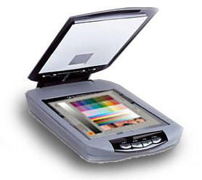

**Fig: Mobile based Camera**

**Image Enhancement:**

**Image enhancement** is among the simplest and most appealing areas of digital image processing. Basically, the idea behind enhancement techniques is to bring out detail that is obscured, or simply to highlight certain features of interesting an image. A familiar example of enhancement is when we increase the contrast of an image because “it looks better.” It is important to keep in mind that enhancement is a very subjective area of image processing.

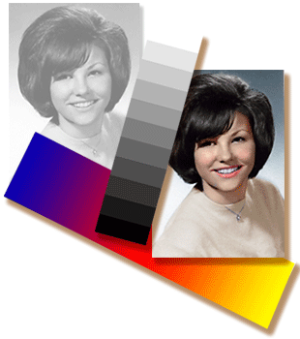  
**Fig: Image enhancement process for Gray Scale Image and Colour Image using Histogram Bits**

**1.5.3 Image restoration:**

**Image restoration** is an area that also deals with improving the appearance of an image. However, unlike enhancement, which is subjective, image restoration is objective, in the sense that restoration techniques tend to be based on mathematical or probabilistic models of image degradation.

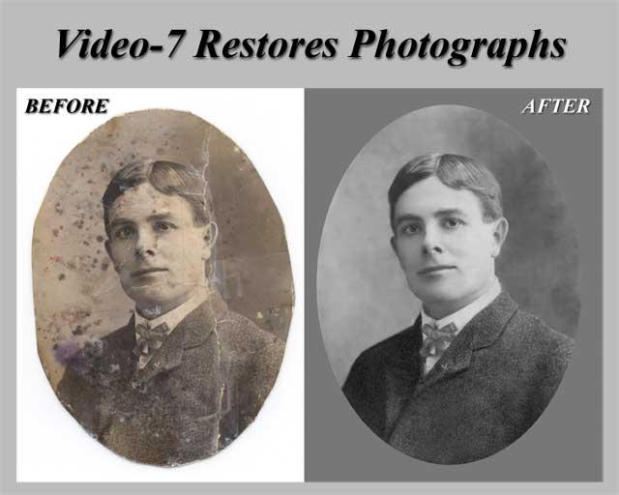

Fig: Noise image🡪 Image Enhancement

Enhancement, on the other hand, is based on human subjective preferences regarding what constitutes a “good” enhancement result. For example, contrast stretching is considered an enhancement technique because it is based primarily on the pleasing aspects it might present to the viewer, where as removal of image blur by applying a deblurring function is considered a restoration technique.

**Color image processing:**

The use of color in image processing is motivated by two principal factors. First, color is a powerful descriptor that often simplifies object identification and extraction from a scene. Second, humans can discern thousands of color shades and intensities, compared to about only two dozen shades of gray. This second factor is particularly important in manual image analysis.

**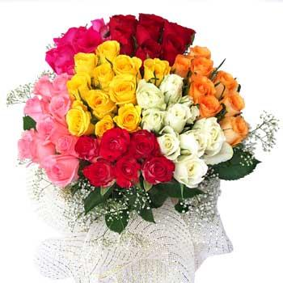**

**Fig: gray Scale image 🡪 Colour Image**

**Segmentation:**

**Segmentation** procedures partition an image into its constituent parts or objects. In general, autonomous segmentation is one of the most difficult tasks in digital image processing. A rugged segmentation procedure brings the process a long way toward successful solution of imaging problems that require objects to be identified individually.

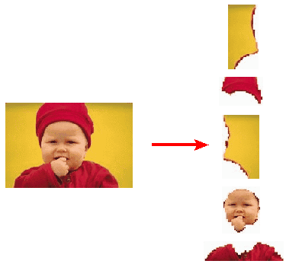

**Fig: Image Segment Process**

On the other hand, weak or erratic segmentation algorithms almost always guarantee eventual failure. In general, the more accurate the segmentation, the more likely recognition is to succeed.

Digital image is defined as a two dimensional function f(x, y), where x and y are spatial (plane) coordinates, and the amplitude of f at any pair of coordinates (x, y) is called intensity or grey level of the image at that point. The field of digital image processing refers to processing digital images by means of a digital computer. The digital image is composed of a finite number of elements, each of which has a particular location and value. The elements are referred to as picture elements, image elements, pels, and pixels. Pixel is the term most widely used.

**Image Compression**

Digital Image compression addresses the problem of reducing the amount of data required to represent a digital image. The underlying basis of the reduction process is removal of redundant data. From the mathematical viewpoint, this amounts to transforming a 2D pixel array into a statically uncorrelated data set. The data redundancy is not an abstract concept but a mathematically quantifiable entity. If n1 and n2 denote the number of information-carrying units in two data sets that represent the same information, the relative data redundancy  [2] of the first data set (the one characterized by n1) can be defined as,



Where  called as compression ratio [2]. It is defined as

= 

In image compression, three basic data redundancies can be identified and exploited: Coding redundancy, interpixel redundancy, and phychovisal redundancy. Image compression is achieved when one or more of these redundancies are reduced or eliminated. The image compression is mainly used for image transmission and storage. Image transmission applications are in broadcast television; remote sensing via satellite, air-craft, radar, or sonar; teleconferencing; computer communications; and facsimile transmission. Image storage is required most commonly for educational and business documents, medical images that arise in computer tomography (CT), magnetic resonance imaging (MRI) and digital radiology, motion pictures, satellite images, weather maps, geological surveys, and so on.

**Image Compression Model**

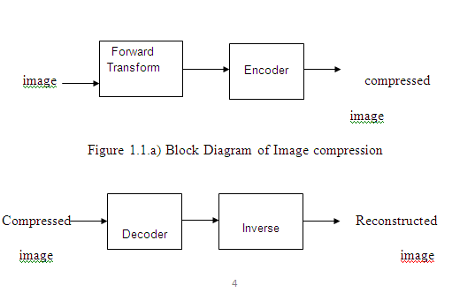

Fig:1.1b) Decompression Process for Image

**Image Compression Types**

There are two types’ image compression techniques.

1. Lossy Image compression

2. Lossless Image compression

Compression ratio:

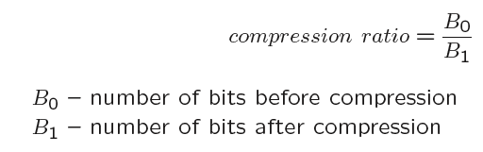

**1. Lossy Image compression :**

Lossy compression provides higher levels of data reduction but result in a less than perfect reproduction of the original image. It provides high compression ratio. lossy image compression is useful in applications such as broadcast television, videoconferencing, and facsimile transmission, in which a certain amount of error is an acceptable trade-off for increased compression performance. Originally, PGF has been designed to quickly and progressively decode lossy compressed aerial images. A lossy compression mode has been preferred, because in an application like a terrain explorer texture data (e.g., aerial orthophotos) is usually mid-mapped filtered and therefore lossy mapped onto the terrain surface. In addition, decoding lossy compressed images is usually faster than decoding lossless compressed images.

In the next test series we evaluate the lossy compression efficiency of PGF. One of the best competitors in this area is for sure JPEG 2000. Since JPEG 2000 has two different filters, we used the one with the better trade-off between compression efficiency and runtime. On our machine the 5/3 filter set has a better trade-off than the other. However, JPEG 2000 has in both cases a remarkable good compression efficiency for very high compression ratios but also a very poor encoding and decoding speed. The other competitor is JPEG. JPEG is one of the most popular image file formats.

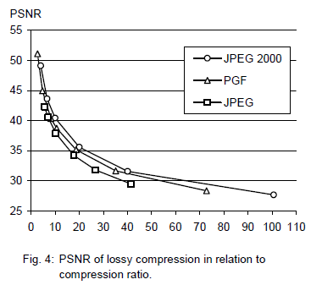

It is very fast and has a reasonably good compression efficiency for a wide range of compression ratios. The drawbacks of JPEG are the missing lossless compression and the often missing progressive decoding. Fig. 4 depicts the average rate-distortion behavior for the images in the Kodak test set when fixed (i.e., nonprogressive) lossy compression is used. The PSNR of PGF is on average 3% smaller than the PSNR of JPEG 2000, but 3% better than JPEG.

These results are also qualitative valid for our PGF test set and they are characteristic for aerial ortho-photos and natural images. Because of the design of PGF we already know that PGF does not reach the compression efficiency of JPEG 2000. However, we are interested in the trade-off between compression efficiency and runtime. To report this trade-off we show in Table 4 a comparison between JPEG 2000 and PGF and in Fig. 5 (on page 8) we show for the same test series as in Fig. 4 the corresponding average decoding times in relation to compression ratios.Table 4 contains for seven different compression ratios (mean values over the compression ratios of the eight images of the Kodak test set) the corresponding average encoding and decoding times in relation to the average PSNR values. In case of PGF the encoding time is always slightly longer than the corresponding decoding time. The reason for that is that the actual encoding phase (cf. Subsection 2.4.2) takes slightly longer than the corresponding decoding phase. For six of seven ratios the PSNR difference between JPEG 2000 and PGF is within 3% of the PSNR of JPEG 2000. Only in the first row is the difference larger (21%), but because a PSNR of 50 corresponds to an almost perfect image quality the large PSNR difference corresponds with an almost undiscoverable visual difference. The price they pay in JPEG 2000 for the 3% more PSNR is very high. The creation of a PGF is five to twenty times faster than the creation of a corresponding JPEG 2000 file, and the decoding of the created PGF is still five to ten times faster than the decoding of the JPEG 2000 file. This gain in speed is remarkable, especially in areas where time is more important than quality, maybe for instance in real-time computation.

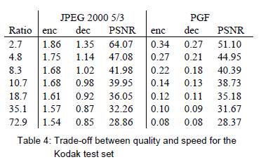

In Fig. 5 we see that the price we pay in PGF for the 3% more PSNR than JPEG is low: for small compression ratios (< 9) decoding in PGF takes two times longer than JPEG and for higher compression ratios (> 30) it takes only ten percent longer than JPEG. These test results are characteristic for both natural images and aerial ortho-photos. Again, in the third test series we only use the ‘Lena’ image. We run our lossy coder with six different quantization parameters and measure the PSNR in relation to the resulting compression ratios. The results (ratio: PSNR) are:

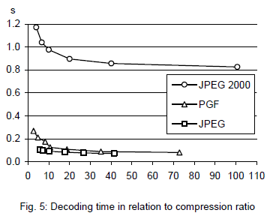

**2.Lossless Image compression :**

Lossless Image compression is the only acceptable amount of data reduction. It provides low compression ratio while compared to lossy. In Lossless Image compression techniques are composed of two relatively independent operations: (1) devising an alternative representation of the image in which its interpixel redundancies are reduced and (2) coding the representation to eliminate coding redundancies.

Lossless Image compression is useful in applications such as medical imaginary, business documents and satellite images.Table 2 summarizes the lossless compression efficiency and Table 3 the coding times of the PGF test set. For WinZip we only provide average runtime values, because of missing source code we have to use an interactive testing procedure with runtimes measured by hand. All other values are measured in batch mode.

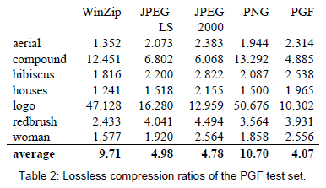

In Table 2 it can be seen that in almost all cases the best compression ratio is obtained by JPEG 2000, followed by PGF, JPEG-LS, and PNG. This result is different to the result in [SEA+00], where the best performance for a similar test set has been reported for JPEG-LS. PGF performs between 0.5% (woman) and 21.3% (logo) worse than JPEG 2000. On average it is almost 15% worse. The two exceptions to the general trend are the ‘compound’ and the ‘logo’ images. Both images contain for the most part black text on a white background. For this type of images, JPEG-LS and in particular WinZip and PNG provide much larger compression ratios. However, in average PNG performs the best, which is also reported in [SEA+00].

These results show, that as far as lossless compression is concerned, PGF performs reasonably well on natural and aerial images. In specific types of images such as ‘compound’ and ‘logo’ PGF is outperformed by far in PNG.

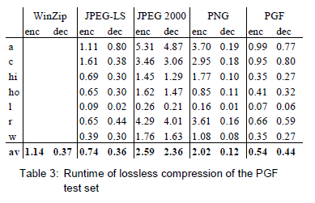

Table 3 shows the encoding (enc) and decoding (dec) times (measured in seconds) for the same algorithms and images as in Table 2. JPEG 2000 and PGF are both symmetric algorithms, while WinZip, JPEG-LS and in particular PNG are asymmetric with a clearly shorter decoding than encoding time. JPEG 2000, the slowest in encoding and decoding, takes more than four times longer than PGF. This speed gain is due to the simpler coding phase of PGF. JPEG-LS is slightly slower than PGF during encoding, but slightly faster in decoding images.

WinZip and PNG decode even more faster than JPEG-LS, but their encoding times are also worse. PGF seems to be the best compromise between encoding and decoding times.

Our PGF test set clearly shows that PGF in lossless mode is best suited for natural images and aerial ortho photos. PGF is the only algorithm that encodes the three Mega Byte large aerial ortho photo in less than second without a real loss of compression efficiency. For this particular image the efficiency loss is less than three percent compared to the best. These results should be underlined with our second test set, the Kodak test set.

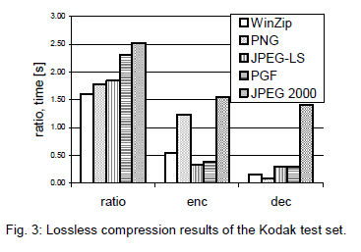

Fig. 3 shows the averages of the compression ratios (ratio), encoding (enc), and decoding (dec) times over all eight images. JPEG 2000 shows in this test set the best compression efficiency followed by PGF, JPEG-LS, PNG, and WinZip. In average PGF is eight percent worse than JPEG 2000. The fact that JPEG 2000 has a better lossless compression ratio than PGF does not surprise,

because JPEG 2000 is more quality driven than PGF.

However, it is remarkable that PGF is clearly better than JPEG-LS (+21%) and PNG (+23%) for natural images. JPEG-LS shows in the Kodak test set also a symmetric encoding and decoding time behaviour. It is encoding and decoding times are almost equal to PGF. Only PNG and WinZip can faster decode than PGF, but they also take longer than PGF to encode.

If both compression efficiency and runtime is important, then PGF is clearly the best of the tested algorithms for lossless compression of natural images and aerial ortho photos. In the third test we perform our lossless coder on the ‘Lena’ image.

To digitally process an image, it is first necessary to reduce the image to a series of numbers that can be manipulated by the computer. Each number representing the brightness value of the image at a particular location is called a picture element, or pixel. A typical digitized image may have 512 × 512 or roughly 250,000 pixels, although much larger images are becoming common. Once the image has been digitized, there are three basic operations that can be performed on it in the computer. For a point operation, a pixel value in the output image depends on a single pixel value in the input image. For local operations, several neighbouring pixels in the input image determine the value of an output image pixel. In a global operation, all of the input image pixels contribute to an output image pixel value.

Correspondingly, these combinations attempt to strike a winning tradeoff: be flexible and hence bring tolerance toward intraclass variation, while also being discriminative enough to be robust to background clutter and interclass similarity. An important feature of our contour-based recognition approach is that it affords us substantial flexibility to incorporate additional image information. Specifically, we extend the contour-based recognition method and propose a new hybrid recognition method which exploits shape tokens and SIFT features as recognition cues. Shape-tokens and SIFT features are largely orthogonal, where the former corresponds to shape boundaries and the latter to sparse salient image patches. Here, each learned combination can comprise features that are either 1) purely shape-tokens, 2) purely SIFT features, or 3) a mixture of shape-tokens and SIFT features. The number and types of features to be combined together are learned automatically from training images, and represent the more discriminative ones based on the training set. Consequently, by imparting these two degrees of variability (in both the number and the types of features) to a combination, we empower it with even greater flexibility and discriminative potential. A shorter version of this paper appeared in [9].

**CLASSIFICATION OF IMAGES:**

There are 3 types of images used in Digital Image Processing. They are

1. Binary Image
2. Gray Scale Image
3. Colour Image

**BINARY IMAGE:**

A binary image is a [digital image](http://en.wikipedia.org/wiki/Digital_image) that has only two possible values for each [pixel](http://en.wikipedia.org/wiki/Pixel).  Typically the two colors used for a binary image are black and white though any two colors can be used.  The color used for the object(s) in the image is the foreground color while the rest of the image is the background color.

Binary images are also called bi-level or two-level. This means that each pixel is stored as a single bit (0 or 1).This name black and white, monochrome or monochromatic are often used for this concept, but may also designate any images that have only one sample per pixel, such as [grayscale images](http://en.wikipedia.org/wiki/Grayscale)

Binary images often arise in [digital image processing](http://en.wikipedia.org/wiki/Digital_image_processing) as [masks](http://en.wikipedia.org/w/index.php?title=Mask_(image_processing)&action=edit&redlink=1) or as the result of certain operations such as [segmentation](http://en.wikipedia.org/wiki/Segmentation_(image_processing)), [thresholding](http://en.wikipedia.org/wiki/Thresholding_(image_processing)), and [dithering](http://en.wikipedia.org/wiki/Dither). Some input/output devices, such as [laser printers](http://en.wikipedia.org/wiki/Laser_printer), [fax machines](http://en.wikipedia.org/wiki/Fax), and bi-level [computer displays](http://en.wikipedia.org/wiki/Visual_display_unit), can only handle bi-level images

**GRAY SCALE IMAGE**

A grayscale Image is [digital image](http://en.wikipedia.org/wiki/Digital_image) is an image in which the value of each [pixel](http://en.wikipedia.org/wiki/Pixel) is a single [sample](http://en.wikipedia.org/wiki/Sample_(signal)), that is, it carries only [intensity](http://en.wikipedia.org/wiki/Luminous_intensity) information. Images of this sort, also known as [black-and-white](http://en.wikipedia.org/wiki/Black-and-white), are composed exclusively of shades of [gray](http://en.wikipedia.org/wiki/Gray)(0-255), varying from black(0) at the weakest intensity to white(255) at the strongest.

Grayscale images are distinct from one-bit [black-and-white](http://en.wikipedia.org/wiki/Black-and-white) images, which in the context of computer imaging are images with only the two [colors](http://en.wikipedia.org/wiki/Color), [black](http://en.wikipedia.org/wiki/Black), and [white](http://en.wikipedia.org/wiki/White) (also called bi-level or [binary images](http://en.wikipedia.org/wiki/Binary_image)). Grayscale images have many shades of gray in between. Grayscale images are also called [monochromatic](http://en.wikipedia.org/wiki/Monochromatic), denoting the absence of any [chromatic](http://en.wikipedia.org/wiki/Chromaticity) variation.

Grayscale images are often the result of measuring the intensity of light at each pixel in a single band of the [electromagnetic spectrum](http://en.wikipedia.org/wiki/Electromagnetic_spectrum) (e.g. [infrared](http://en.wikipedia.org/wiki/Infrared), [visible light](http://en.wikipedia.org/wiki/Visible_spectrum), [ultraviolet](http://en.wikipedia.org/wiki/Ultraviolet), etc.), and in such cases they are monochromatic proper when only a given [frequency](http://en.wikipedia.org/wiki/Frequency) is captured. But also they can be synthesized from a full color image; see the section about converting to grayscale.

**COLOUR IMAGE:**

A (digital) color image is a [digital image](http://en.wikipedia.org/wiki/Digital_image) that includes [color](http://en.wikipedia.org/wiki/Color) information for each [pixel](http://en.wikipedia.org/wiki/Pixel). Each pixel has a particular value which determines its appearing color. This value is qualified by three numbers giving the decomposition of the color in the three primary colors Red, Green and Blue. Any color visible to human eye can be represented this way. The decomposition of a color in the three primary colors is quantified by a number between 0 and 255. For example, white will be coded as R = 255, G = 255, B = 255; black will be known as (R,G,B) = (0,0,0); and say, bright pink will be : (255,0,255).

In other words, an image is an enormous two-dimensional array of color values, pixels, each of them coded on 3 bytes, representing the three primary colors. This allows the image to contain a total of 256x256x256 = 16.8 million different colors. This technique is also known as RGB encoding, and is specifically adapted to human vision

|  |
| --- |
| http://images.gamedev.net/features/programming/imageproc/image004.gif |

**Fig.1 Hue Saturation Process of RGB SCALE Image**

From the above figure, colors are coded on three bytes representing their decomposition on the three primary colors. It sounds obvious to a mathematician to immediately interpret colors as vectors in a three dimension space where each axis stands for one of the primary colors. Therefore we will benefit of most of the geometric mathematical concepts to deal with our colors, such as norms, scalar product, projection, rotation or distance.

**LITERATURE SURVEY :**

1."Deep Learning-Based Real-Time Traffic Sign Recognition System for Urban Environments"

Authors: Multiple contributors

Abstract: This study uses YOLO (You Only Look Once) models (YOLOv3, YOLOv4, and YOLOv5) for traffic sign recognition in real-time applications, such as urban driving environments. YOLO models are combined with tracking algorithms (DeepSORT and StrongSORT) to improve accuracy and robustness in varying conditions.

Published Year: 2023

2."Traffic Sign Detection and Classification Using Convolutional Neural Networks (CNN) and Support Vector Machines (SVM)"

Authors: Various

Abstract: This paper proposes a CNN-SVM hybrid approach, where CNN extracts color features in the YCbCr space, and SVM performs classification. This method aims to improve traffic sign recognition accuracy under variable lighting conditions.

Published Year: 2022

3."A Survey on Traffic Sign Recognition Using Deep Learning Techniques"

Authors: Wei et al.

Abstract: A comprehensive survey that evaluates various deep learning-based methods in traffic sign recognition, especially under challenging conditions. Techniques like HOG, CNN, and template matching are explored for real-world applications.

Published Year: 2020

4."YOLO-Based Real-Time Traffic Sign Detection and Recognition"

Authors: Jeya Visshwak et al.

Abstract: This study emphasizes the YOLO algorithm’s performance for high-speed traffic sign recognition in dynamic environments. The CNN-based framework is tested with road images, enhancing image processing efficiency and real-time usability.

Published Year: 2020

5."Enhanced Small Target Detection Using MF-SSD for Traffic Signs"

Authors: Jin et al.

Abstract: This research introduces MF-SSD, an algorithm combining low- and high-level features to enhance the detection of small targets, which often pose challenges in real-world environments. MF-SSD is optimized for real-time recognition in urban contexts.

Published Year: 2020

6."Deep Transfer Learning for Traffic Sign Recognition"

Authors: Various contributors

Abstract: This paper explores transfer learning to enhance model accuracy by leveraging knowledge from one region's dataset to another. This method reduces the need for extensive data collection, making it more efficient for international or varied regional applications.

Published Year: 2021

**EXISTING SYSTEM:**

SVM

**DISADVANTAGES:**

* Feature Dependence
* Scalability Issues
* Sensitivity to Noise

**PROPOSED SYSTEM:**

* Input video
* Pre processing
* Feature extraction
* YOLO with RCNN

**ADVANTAGES:**

* Complexity
* Scalability Issues
* High accuracy

**BLOCK DIAGRAME:**

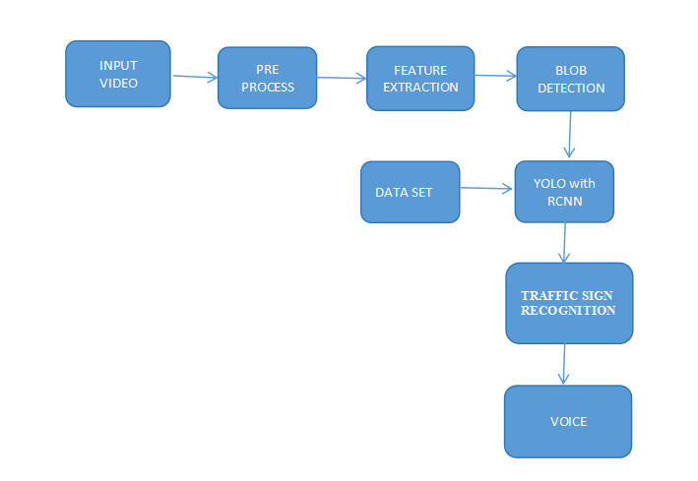

**IMPLEMENTATION MODULE:**

**VIDEO STREAMING**:

Video streaming technology is one way to deliver video over the Internet.  Using streaming technologies, the delivery of audio and video over the Internet can reach many millions of customer using their personal computers, PDAs, mobile smartphones or other streaming devices. The reasons for video streaming technology growth are:

* broadband networks are being deployed
* video and audio compression techniques are more efficient
* quality and variety of audio and video services over internet are increasing

There are two major ways for the transmission of video/audio information over the Internet:

*Download mode.* The content file is completely downloaded and then played. This mode requires long downloading time for the whole content file and requires hard disk space.

*Streaming mode.*The content file is not required to be downloaded completely and it is playing while parts of the content are being received and decoded.

**Pre-processing:**

Pre-processing is a common name for operations with images at the lowest level of abstraction -- both input and output are intensity images.ο The aim of pre-processing is an improvement of the image data that suppresses unwanted distortions or enhances some image features important for further processing

**Blob Detection:**

In computer vision, blob detection methods are aimed at detecting regions in a digital image that differ in properties, such as brightness or color, compared to surrounding regions. Informally, a blob is a region of an image in which some properties are constant or approximately constant; all the points in a blob can be considered in some sense to be similar to each other. The most common method for blob detection is convolution.

Given some property of interest expressed as a function of position on the image, there are two main classes of blob detectors: (i) differential methods, which are based on derivatives of the function with respect to position, and (ii) methods based on local extrema, which are based on finding the local maxima and minima of the function. With the more recent terminology used in the field, these detectors can also be referred to as interest point operators, or alternatively interest region operators (see also interest point detectionand corner detection).

There are several motivations for studying and developing blob detectors. One main reason is to provide complementary information about regions, which is not obtained from edge detectors or corner detectors. In early work in the area, blob detection was used to obtain regions of

**YOLO WITH RCNN:**

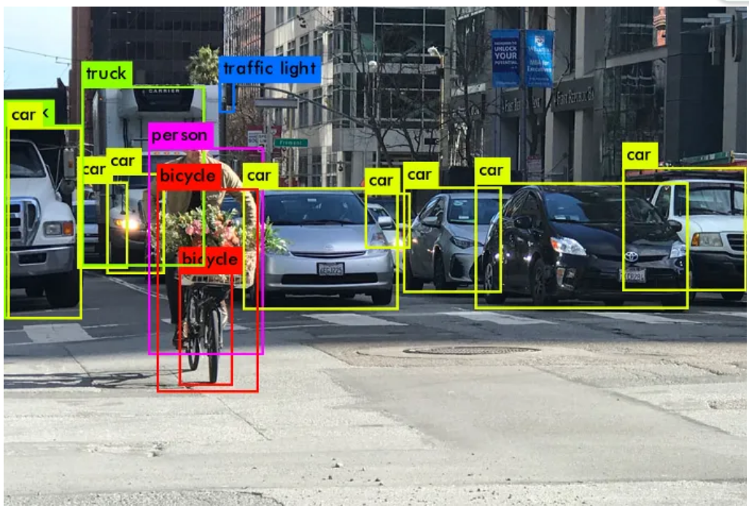

You Only Look Once (YOLO) proposes using an end-to-end neural network that makes predictions of bounding boxes and class probabilities all at once. It differs from the approach taken by previous object detection algorithms, which repurposed classifiers to perform detection. Following a fundamentally different approach to object detection, YOLO achieved state-of-the-art results, beating other real-time object detection algorithms by a large margin. While algorithms like Faster RCNN work by detecting possible regions of interest using the Region Proposal Network and then performing recognition on those regions separately, YOLO performs all of its predictions with the help of a single fully connected layer. Methods that use Region Proposal Networks perform multiple iterations for the same image, while YOLO gets away with a single iteration. Several new versions of the same model have been proposed since the initial release of YOLO in 2015, each building on and improving its predecessor. Here's a timeline showcasing YOLO's development in recent years.

The YOLO algorithm takes an image as input and then uses a simple deep convolutional neural network to detect objects in the image. The architecture of the CNN model that forms the backbone of YOLO is shown below.

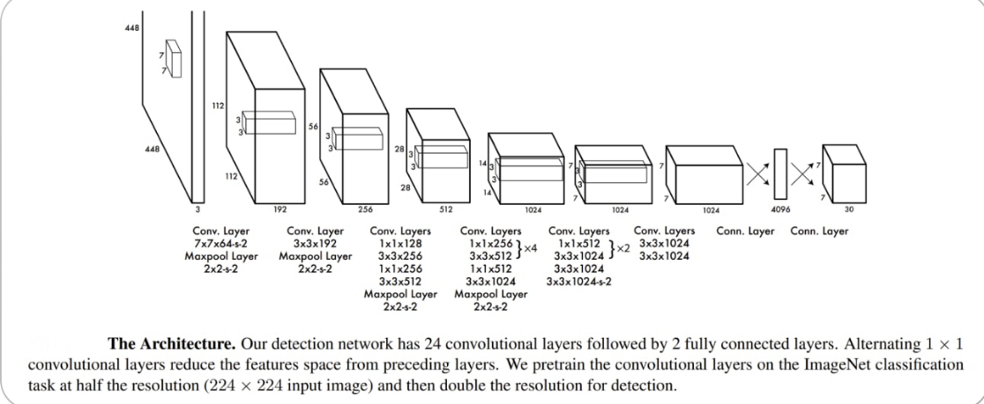

The first 20 convolution layers of the model are pre-trained using ImageNet by plugging in a temporary average pooling and fully connected layer. Then, this pre-trained model is converted to perform detection since previous research showcased that adding convolution and connected layers to a pre-trained network improves performance. YOLO’s final fully connected layer predicts both class probabilities and bounding box coordinates.

YOLO divides an input image into an S × S grid. If the center of an object falls into a grid cell, that grid cell is responsible for detecting that object. Each grid cell predicts B bounding boxes and confidence scores for those boxes. These confidence scores reflect how confident the model is that the box contains an object and how accurate it thinks the predicted box is.

YOLO predicts multiple bounding boxes per grid cell. At training time, we only want one bounding box predictor to be responsible for each object. YOLO assigns one predictor to be “responsible” for predicting an object based on which prediction has the highest current IOU with the ground truth. This leads to specialization between the bounding box predictors. Each predictor gets better at forecasting certain sizes, aspect ratios, or classes of objects, improving the overall recall score.

One key technique used in the YOLO models is non-maximum suppression (NMS). NMS is a post-processing step that is used to improve the accuracy and efficiency of object detection. In object detection, it is common for multiple bounding boxes to be generated for a single object in an image. These bounding boxes may overlap or be located at different positions, but they all represent the same object. NMS is used to identify and remove redundant or incorrect bounding boxes and to output a single bounding box for each object in the image.

**SOFTWARE REQUIREMENTS**

**Python: Python** Is An Object-Oriented, High Level Language, Interpreted, Dynamic And Multipurpose Programming Language.

Python Is Easy To Learn Yet Powerful And Versatile Scripting Language Which Makes It Attractive For Application Development.

Python's Syntax And Dynamic Typing With Its Interpreted Nature, Make It An Ideal Language For Scripting And Rapid Application Development In Many Areas.

Python Supports Multiple Programming Pattern, Including Object Oriented Programming, Imperative And Functional Programming Or Procedural Styles.

Python Is Not Intended To Work On Special Area Such As Web Programming. That Is Why It Is Known As Multipurpose Because It Can Be Used With Web, Enterprise, 3d Cad Etc.

We Don't Need To Use Data Types To Declare Variable Because It Is Dynamically Typed So We Can Write A=10 To Declare An Integer Value In A Variable.

Python Makes The Development And Debugging Fast Because There Is No Compilation Step Included In Python Development And Edit-Test-Debug Cycle Is Very Fast.

2. Python Features

#### 1) Easy To Use:

Python Is Easy To Very Easy To Use And High Level Language. Thus It Is Programmer-Friendly Language.

#### 2) Expressive Language:

Python Language Is More Expressive. The Sense Of Expressive Is The Code Is Easily Understandable.

#### 3) Interpreted Language:

Python Is An Interpreted Language I.E. Interpreter Executes The Code Line By Line At A Time. This Makes Debugging Easy And Thus Suitable For Beginners.

#### 4) Cross-Platform Language:

Python Can Run Equally On Different Platforms Such As Windows, Linux, Unix , Macintosh Etc. Thus, Python Is A Portable Language.

#### 5) Free And Open Source:

Python Language Is Freely Available(Www.Python.Org).The Source-Code Is Also Available. Therefore It Is Open Source.

#### 6) Object-Oriented Language:

Python Supports Object Oriented Language. Concept Of Classes And Objects Comes Into Existence.

#### 7) Extensible:

It Implies That Other Languages Such As C/C++ Can Be Used To Compile The Code And Thus It Can Be Used Further In Your Python Code.

#### 8) Large Standard Library:

Python Has A Large And Broad Library.

#### 9) Gui Programming:

Graphical User Interfaces Can Be Developed Using Python.

#### 10) Integrated:

It Can Be Easily Integrated With Languages Like C, C++, Java Etc.

3. Python History

* Python Laid Its Foundation In The Late 1980s.
* The Implementation Of Python Was Started In The December 1989 By **Guido Van Rossum** At Cwi In Netherland.
* Abc Programming Language Is Said To Be The Predecessor Of Python Language Which Was Capable Of Exception Handling And Interfacing With Amoeba Operating System.
* Python Is Influenced By Programming Languages Like:
  + Abc Language.
  + Modula-3

# 5. Python Applications

Python As A Whole Can Be Used In Any Sphere Of Development.

Let Us See What Are The Major Regions Where Python Proves To Be Handy.

#### 1) Console Based Application

Python Can Be Used To Develop Console Based Applications. For Example: **Ipython**.

#### 2) Audio Or Video Based Applications

Python Proves Handy In Multimedia Section. Some Of Real Applications Are: Timplayer, Cplay Etc.

#### 3) 3d Cad Applications

Fandango Is A Real Application Which Provides Full Features Of Cad.

#### 4) Web Applications

Python Can Also Be Used To Develop Web Based Application. Some Important Developments Are: Pythonwikiengines, Pocoo, Pythonblogsoftware Etc.

#### 5) Enterprise Applications

Python Can Be Used To Create Applications Which Can Be Used Within An Enterprise Or An Organization. Some Real Time Applications Are: Openerp, Tryton, Picalo Etc.

#### 6) Applications For Images

Using Python Several Application Can Be Developed For Image. Applications Developed Are: Vpython, Gogh, Imgseek Etc.

There Are Several Such Applications Which Can Be Developed Using Python

# 6. Python Example

Python Code Is Simple And Easy To Run. Here Is A Simple Python Code That Will Print "Welcome To Python".

A Simple Python Example Is Given Below.

1. >>> A="Welcome To Python"
2. >>> Print A
3. Welcome To Python
4. >>>

**Explanation:**

* Here We Are Using Idle To Write The Python Code. Detail Explanation To Run Code Is Given In Execute Python Section.
* A Variable Is Defined Named "A" Which Holds "Welcome To Python".
* "Print" Statement Is Used To Print The Content. Therefore "Print A" Statement Will Print The Content Of The Variable. Therefore, The Output "Welcome To Python" Is Produced.

## Python 3.4 Example

In Python 3.4 Version, You Need To Add Parenthesis () In A String Code To Print It.

1. >>> A=("Welcome To Python Example")
2. >>> Print A
3. Welcome To Python Example
4. >>>

# 7. How To Execute Python

# 7. How To Execute Python

There Are Three Different Ways Of Working In Python:

## 1) Interactive Mode:

You Can Enter Python In The Command Prompt And Start Working With Python.

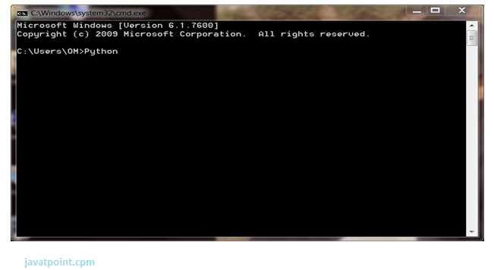

Press Enter Key And The Command Prompt Will Appear Like:

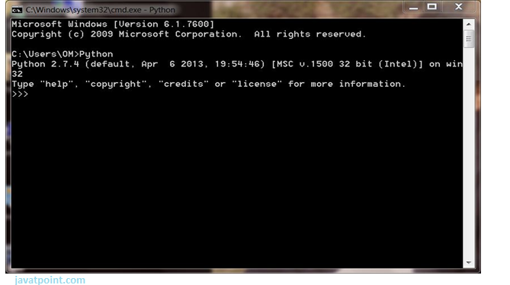

Now You Can Execute Your Python Commands.

**Eg:**

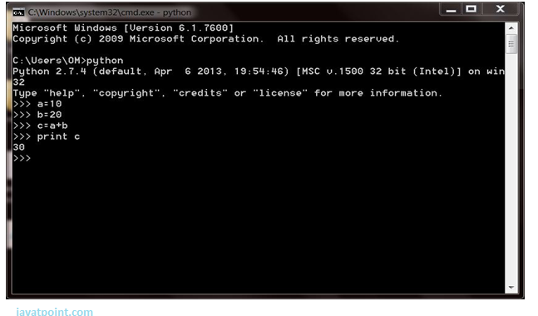

## 2) Script Mode:

Using Script Mode , You Can Write Your Python Code In A Separate File Using Any Editor Of Your Operating System.

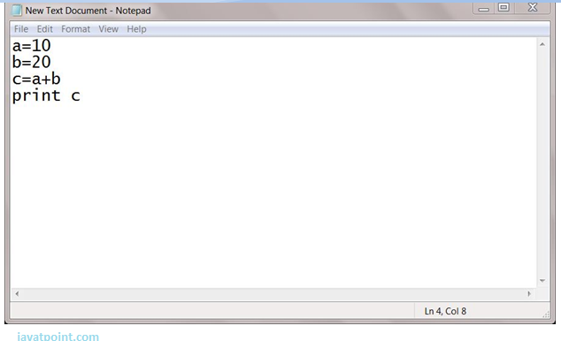

Save It By .Py Extension.

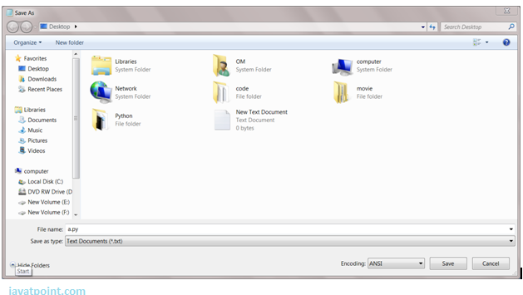

Now Open Command Prompt And Execute It By :

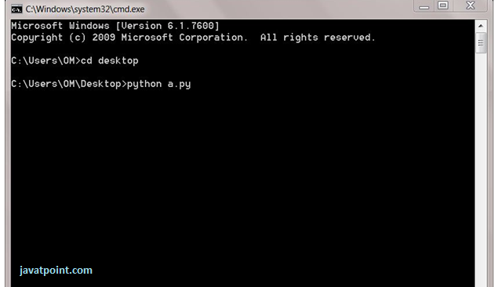

Note: Path In The Command Prompt Should Be Where You Have Saved Your File. In The Above Case File Should Be Saved At Desktop.

## 3) Using Ide: (Integrated Development Environment)

You Can Execute Your Python Code Using A Graphical User Interface (Gui).

All You Need To Do Is:

Click On Start Button -> All Programs -> Python -> Idle(Python Gui)

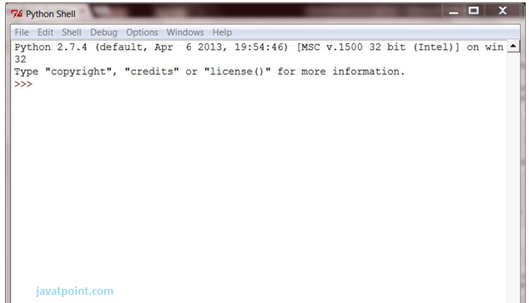

You Can Use Both Interactive As Well As Script Mode In Ide.

**1) Using Interactive Mode:**

Execute Your Python Code On The Python Prompt And It Will Display Result Simultaneously.

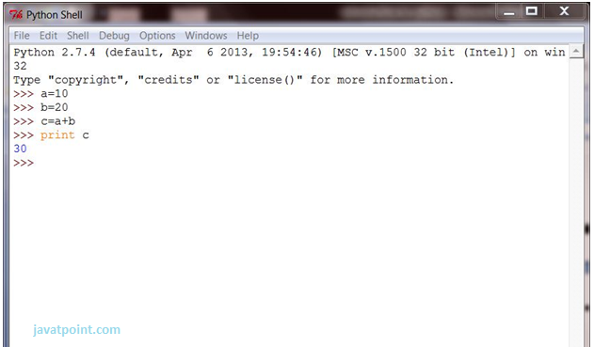

**2) Using Script Mode:**

I) Click On Start Button -> All Programs -> Python -> Idle(Python Gui)

Ii) Python Shell Will Be Opened. Now Click On File -> New Window.

A New Editor Will Be Opened . Write Your Python Code Here.

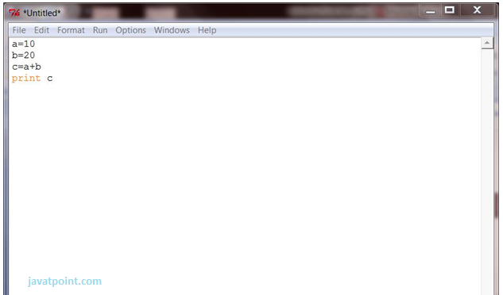

Click On File -> Save As

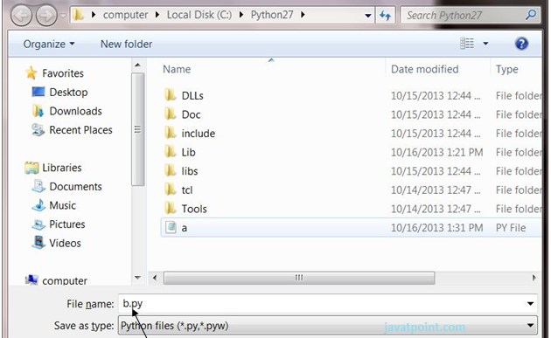

Run Then Code By Clicking On Run In The Menu Bar.

Run -> Run Module

Result Will Be Displayed On A New Python Shell As:

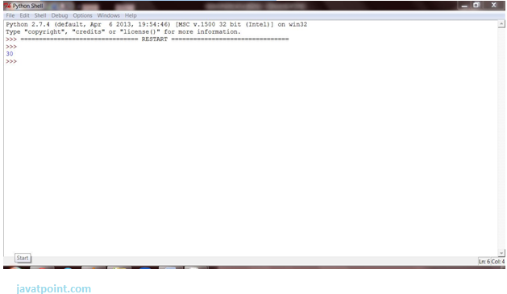

**1) Using Interactive Mode:**

Execute Your Python Code On The Python Prompt And It Will Display Result Simultaneously.

**2) Using Script Mode:**

I) Click On Start Button -> All Programs -> Python -> Idle(Python Gui)

Ii) Python Shell Will Be Opened. Now Click On File -> New Window.

A New Editor Will Be Opened . Write Your Python Code Here.

Run Then Code By Clicking On Run In The Menu Bar.

Run -> Run Module

Result Will Be Displayed On A New Python Shell As:

* **Opencv:**

**Introduction To Computer Vision**

Using Software To Parse The World’s Visual Content Is As Big Of A Revolution In Computing As Mobile Was 10 Years Ago, And Will Provide A Major Edge For Developers And Businesses To Build Amazing Products.

Computer Vision Is The Process Of Using Machines To Understand And Analyze Imagery (Both Photos And Videos). While These Types Of Algorithms Have Been Around In Various Forms Since The 1960’s, Recent Advances In [Machine Learning](https://blog.algorithmia.com/introduction-to-machine-learning/), As Well As Leaps Forward In Data Storage, Computing Capabilities, And Cheap High-Quality Input Devices, Have Driven Major Improvements In How Well Our Software Can Explore This Kind Of Content.

**What Is Computer Vision?**

Computer Vision Is The Broad Parent Name For Any Computations Involving Visual Content – That Means Images, Videos, Icons, And Anything Else With Pixels Involved. But Within This Parent Idea, There Are A Few Specific Tasks That Are Core Building Blocks:

* In **Object Classification**, You Train A Model On A Dataset Of Specific Objects, And The Model Classifies New Objects As Belonging To One Or More Of Your Training Categories.
* For **Object Identification**, Your Model Will Recognize A Specific Instance Of An Object – For Example, Parsing Two Faces In An Image And Tagging One As Tom Cruise And One As Katie Holmes.

A Classical Application Of Computer Vision Is Handwriting Recognition For Digitizing Handwritten Content (We’ll Explore More Use Cases Below). Outside Of Just Recognition, Other Methods Of Analysis Include:

* Video **Motion Analysis** Uses Computer Vision To Estimate The Velocity Of Objects In A Video, Or The Camera Itself.
* In **Image Segmentation**, Algorithms Partition Images Into Multiple Sets Of Views.
* **Scene Reconstruction** Creates A 3d Model Of A Scene Inputted Through Images Or Video (Check Out [Selva](https://www.selva3d.com/)).
* In **Image Restoration**, Noise Such As Blurring Is Removed From Photos Using Machine Learning Based Filters.

Any Other Application That Involves Understanding Pixels Through Software Can Safely Be Labeled As Computer Vision.

**How Computer Vision Works**

One Of The Major Open Questions In Both Neuroscience And Machine Learning Is: How Exactly Do Our Offense and non-offenses Work, And How Can We Approximate That With Our Own Algorithms? The Reality Is That There Are Very Few Working And Comprehensive Theories Of Offense and non-offense Computation; So Despite The Fact That Neural Nets Are Supposed To “Mimic The Way The Offense and non-offense Works,” Nobody Is Quite Sure If That’s Actually True. Jeff Hawkins Has An [Entire Book On This Topic Called On Intelligence](https://www.amazon.com/Intelligence-Understanding-Creation-Intelligent-Machines/dp/0805078533).

The Same Paradox Holds True For Computer Vision – Since We’re Not Decided On How The Offense and non-offense And Eyes Process Images, It’s Difficult To Say How Well The Algorithms Used In Production Approximate Our Own Internal Mental Processes. For Example, [Studies Have Shown](https://www.technologyreview.com/s/508376/in-a-frogs-eye/) That Some Functions That We Thought Happen In The Offense and non-offense Of Frogs Actually Take Place In The Eyes. We’re A Far Cry From Amphibians, But Similar Uncertainty Exists In Human Cognition.

Machines Interpret Images Very Simply: As A Series Of Pixels, Each With Their Own Set Of Color Values. Consider The Simplified Image Below, And How Grayscale Values Are Converted Into A Simple Array Of Numbers:

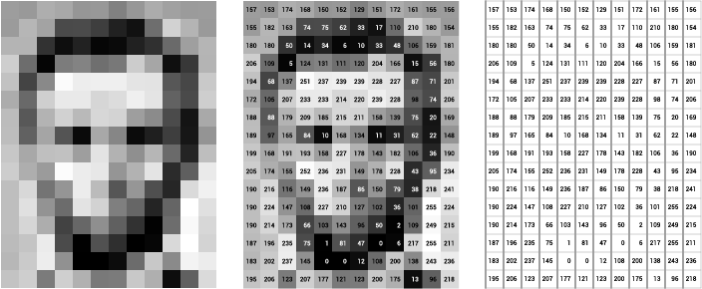

Source: [Openframeworks](http://openframeworks.cc/ofBook/chapters/image_processing_computer_vision.html)

Think Of An Image As A Giant Grid Of Different Squares, Or Pixels (This Image Is A Very Simplified Version Of What Looks Like Either Abraham Lincoln Or A Dementor). Each Pixel In An Image Can Be Represented By A Number, Usually From 0 – 255. The Series Of Numbers On The Right Is What Software Sees When You Input An Image. For Our Image, There Are 12 Columns And 16 Rows, Which Means There Are 192 Input Values For This Image.

When We Start To Add In Color, Things Get More Complicated. Computers Usually Read Color As A Series Of 3 Values – Red, Green, And Blue (Rgb) – On That Same 0 – 255 Scale. Now, Each Pixel Actually Has 3 Values For The Computer To Store In Addition To Its Position. If We Were To Colorize President Lincoln (Or Harry Potter’s Worst Fear), That Would Lead To 12 X 16 X 3 Values, Or 576 Numbers.

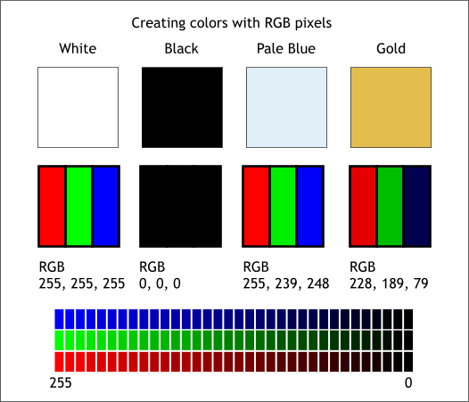

Source: [Xaraxone](http://archive.xaraxone.com/webxealot/workbook35/page_5.htm)

For Some Perspective On How Computationally Expensive This Is, Consider This Tree:

* Each Color Value Is Stored In 8 Bits.
* 8 Bits X 3 Colors Per Pixel = 24 Bits Per Pixel.
* A Normal Sized 1024 X 768 Image X 24 Bits Per Pixel = Almost 19m Bits, Or About 2.36 Megabytes.

That’s A Lot Of Memory To Require For One Image, And A Lot Of Pixels For An Algorithm To Iterate Over. But To Train A Model With Meaningful Accuracy – Especially When You’re Talking About [Deep Learning](https://blog.algorithmia.com/introduction-to-deep-learning/) – You’d Usually Need Tens Of Thousands Of Images, And The More The Merrier. Even If You Were To Use [Transfer Learning](https://en.wikipedia.org/wiki/Transfer_learning) To Use The Insights Of An Already Trained Model, You’d Still Need A Few Thousand Images To Train Yours On.

With The Sheer Amount Of Computing Power And Storage Required Just To Train Deep Learning Models For Computer Vision, It’s Not Hard To Understand Why Advances In Those Two Fields Have Driven Machine Learning Forward To Such A Degree.

**Business Use Cases For Computer Vision**

Computer Vision Is One Of The Areas In Machine Learning Where Core Concepts Are Already Being Integrated Into Major Products That We Use Every Day. [Google Is Using Maps](https://research.googleblog.com/2017/05/updating-google-maps-with-deep-learning.html) To Leverage Their Image Data And Identify Street Names, Businesses, And Office Buildings. Facebook Is Using Computer Vision To Identify People In Photos, And Do A Number Of Things With That Information.

But It’s Not Just Tech Companies That Are Leverage Machine Learning For Image Applications. Ford, The American Car Manufacturer That Has Been Around [Literally Since The Early 1900’s](https://en.wikipedia.org/wiki/Ford_Motor_Company), Is [Investing Heavily In Autonomous Vehicles (Avs)](https://media.ford.com/content/fordmedia/fna/us/en/news/2016/08/16/ford-targets-fully-autonomous-vehicle-for-ride-sharing-in-2021.html). Much Of The Underlying Technology In Avs Relies On Analyzing The Multiple Video Feeds Coming Into The Car And Using Computer Vision To Analyze And Pick A Path Of Action.

Another Major Area Where Computer Vision Can Help Is In The Medical Field. Much Of Diagnosis Is Image Processing, Like Reading X-Rays, Mri Scans, And Other Types Of Diagnostics. [Google Has Been Working With Medical Research Teams](https://research.google.com/teams/brain/healthcare/) To Explore How Deep Learning Can Help Medical Workflows, And Have Made Significant Progress In Terms Of Accuracy. To Paraphrase From Their Research Page:

“Collaborating Closely With Doctors And International Healthcare Systems, We Developed A State-Of-The-Art Computer Vision System For Reading Retinal Fundus Images For Diabetic Retinopathy And Determined Our Algorithm’s Performance Is On Par With U.S. Board-Certified Ophthalmologists. We’ve Recently Published Some Of Our Research In The [Journal Of The American Medical Association](https://research.google.com/pubs/archive/45732.pdf) And Summarized The Highlights In A [Blog Post](https://research.googleblog.com/2016/11/deep-learning-for-detection-of-diabetic.html).”

But Aside From The Groundbreaking Stuff, It’s Getting Much Easier To Integrate Computer Vision Into Your Own Applications. A Number Of High-Quality Third Party Providers Like Clarifai Offer [A Simple Api For Tagging And Understanding Images](https://www.clarifai.com/), While Kairos [Provides Functionality Around Facial Recognition](https://www.kairos.com/). We’ll Dive Into The Open-Source Packages Available For Use Below.

**Computer Vision On Algorithmia**

Algorithmia Makes It Easy To Deploy Computer Vision Applications As Scalable Microservices. Our Marketplace Has A Few Algorithms To Help Get The Job Done:

* [Salnet](https://algorithmia.com/algorithms/deeplearning/SalNet) Automatically Identifies The Most Important Parts Of An Image
* [Nudity Detection](https://algorithmia.com/algorithms/sfw/NudityDetectioni2v) Detects Nudity In Pictures
* [Emotion Recognition](https://algorithmia.com/algorithms/deeplearning/EmotionRecognitionCNNMBP) Parses Emotions Exhibited In Images
* [Deepstyle](https://demos.algorithmia.com/deep-style/) Transfers Next-Level Filters Onto Your Image
* [Face Recognition](https://algorithmia.com/algorithms/cv/FaceRecognition)…Recognizes Faces.
* [Image Memorability](https://algorithmia.com/algorithms/deeplearning/LargescaleImageMemorability) Judges How Memorable An Image Is.

A Typical Workflow For Your Product Might Involve Passing Images From A Security Camera Into Emotion Recognition And Raising A Flag If Any Aggressive Emotions Are Exhibited, Or Using Nudity Detection To Block Inappropriate Profile Pictures On Your Web Application.

For A More Detailed Exploration Of How You Can Use The Algorithmia Platform To Implement Complex And Useful Computer Vision Tasks,

### Computer Vision Resources

##### Packages And Frameworks

[Opencv](https://opencv.org/) – “Opencv Was Designed For Computational Efficiency And With A Strong Focus On Real-Time Applications. Adopted All Around The World, Opencv Has More Than 47 Thousand People Of User Community And Estimated Number Of Downloads Exceeding 14 Million. Usage Ranges From Interactive Art, To Mines Inspection, Stitching Maps On The Web Or Through Advanced Robotics.”

[Simplecv](http://simplecv.org/) – “Simplecv Is An Open Source Framework For Building Computer Vision Applications. With It, You Get Access To Several High-Powered Computer Vision Libraries Such As Opencv – Without Having To First Learn About Bit Depths, File Formats, Color Spaces, Buffer Management, Eigenvalues, Or Matrix Versus Bitmap Storage.”

[Mahotas](http://mahotas.readthedocs.io/en/latest/) – “Mahotas Is A Computer Vision And Image Processing Library For Python. It Includes Many Algorithms Implemented In C++ For Speed While Operating In Numpy Arrays And With A Very Clean Python Interface. Mahotas Currently Has Over 100 Functions For Image Processing And Computer Vision And It Keeps Growing.

* **Num Py:**
* Numpy, Which Stands For Numerical Python, Is A Library Consisting Of Multidimensional Array Objects And A Collection Of Routines For Processing Those Arrays. Using Numpy, Mathematical And Logical Operations On Arrays Can Be Performed. This Tutorial Explains The Basics Of Numpy Such As Its Architecture And Environment. It Also Discusses The Various Array Functions, Types Of Indexing, Etc. An Introduction To Matplotlib Is Also Provided. All This Is Explained With The Help Of Examples For Better Understanding.
* Audience
* This Tutorial Has Been Prepared For Those Who Want To Learn About The Basics And Various Functions Of Numpy. It Is Specifically Useful For Algorithm Developers. After Completing This Tutorial, You Will Find Yourself At A Moderate Level Of Expertise From Where You Can Take Yourself To Higher Levels Of Expertise.
* Prerequisites
* You Should Have A Basic Understanding Of Computer Programming Terminologies. A Basic Understanding Of Python And Any Of The Programming Languages Is A Plus.
* Numpy Is A Python Package. It Stands For 'Numerical Python'. It Is A Library Consisting Of Multidimensional Array Objects And A Collection Of Routines For Processing Of Array.

**Numeric**, The Ancestor Of Numpy, Was Developed By Jim Hugunin. Another Package Numarray Was Also Developed, Having Some Additional Functionalities. In 2005, Travis Oliphant Created Numpy Package By Incorporating The Features Of Numarray Into Numeric Package. There Are Many Contributors To This Open Source Project.

## Operations Using Numpy

Using Numpy, A Developer Can Perform The Following Operations −

* Mathematical And Logical Operations On Arrays.
* Fourier Transforms And Routines For Shape Manipulation.
* Operations Related To Linear Algebra. Numpy Has In-Built Functions For Linear Algebra And Random Number Generation.

## Numpy – A Replacement For Matlab

Numpy Is Often Used Along With Packages Like **Scipy** (Scientific Python) And **Mat−Plotlib** (Plotting Library). This Combination Is Widely Used As A Replacement For Matlab, A Popular Platform For Technical Computing. However, Python Alternative To Matlab Is Now Seen As A More Modern And Complete Programming Language.

The Most Important Object Defined In Numpy Is An N-Dimensional Array Type Called **Ndarray**. It Describes The Collection Of Items Of The Same Type. Items In The Collection Can Be Accessed Using A Zero-Based Index.

Every Item In An Ndarray Takes The Same Size Of Block In The Memory. Each Element In Ndarray Is An Object Of Data-Type Object (Called **Dtype**).

Any Item Extracted From Ndarray Object (By Slicing) Is Represented By A Python Object Of One Of Array Scalar Types. The Following Diagram Shows A Relationship Between Ndarray, Data Type Object (Dtype) And Array Scalar Type −

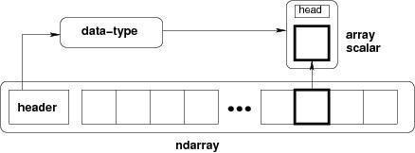

An Instance Of Ndarray Class Can Be Constructed By Different Array Creation Routines Described Later In The Tutorial. The Basic Ndarray Is Created Using An Array Function In Numpy As Follows −

Numpy.Array

It Creates An Ndarray From Any Object Exposing Array Interface, Or From Any Method That Returns An Array.

**Imutils:**

A Series Of Convenience Functions To Make Basic Image Processing Operations Such As Translation, Rotation, Resizing, Skeletonization, And Displaying Matplotlib Images Easier With Opencv And Python.

Transalation

Translation Is The Shifting Of An Image In Either The X Or Y Direction. To Translate An Image In Opencv You Need To Supply The (X, Y)-Shift, Denoted As (Tx, Ty) To Construct The Translation Matrix M:

translation_eq

And From There, You Would Need To Apply The Cv2.Warpaffine  Function.

Instead Of Manually Constructing The Translation Matrix M And Calling Cv2.Warpaffine , You Can Simply Make A Call To The Translate  Function Of Imutils

**Rotation**

Rotating An Image In Opencv Is Accomplished By Making A Call Tocv2.Getrotationmatrix2d  And Cv2.Warpaffine . Further Care Has To Be Taken To Supply The (X, Y)-Coordinate Of The Point The Image Is To Be Rotated About. These Calculation Calls Can Quickly Add Up And Make Your Code Bulky And Less Readable. The Rotate  Function Inimutils  Helps Resolve This Problem.

Resizing

Resizing An Image In Opencv Is Accomplished By Calling The Cv2.Resize  Function. However, Special Care Needs To Be Taken To Ensure That The Aspect Ratio Is Maintained. Thisresize  Function Of Imutils  Maintains The Aspect Ratio And Provides The Keyword Arguments Width  And Height  So The Image Can Be Resized To The Intended Width/Height While (1) Maintaining Aspect Ratio And (2) Ensuring The Dimensions Of The Image Do Not Have To Be Explicitly Computed By The Developer.

Another Optional Keyword Argument, Inter , Can Be Used To Specify Interpolation Method As Well.

Skeletonization Is The Process Of Constructing The “Topological Skeleton” Of An Object In An Image, Where The Object Is Presumed To Be White On A Black Background. Opencv Does Not Provide A Function To Explicity Construct The Skeleton, But Does Provide The Morphological And Binary Functions To Do So.

For Convenience, The Skeletonize  Function Of Imutils  Can Be Used To Construct The Topological Skeleton Of The Image.

The First Argument, Size  Is The Size Of The Structuring Element Kernel. An Optional Argument,Structuring , Can Be Used To Control The Structuring Element — It Defaults Tocv2.Morph\_Rect  , But Can Be Any Valid Structuring Element.

Displaying With Matplotlib

In The Python Bindings Of Opencv, Images Are Represented As Numpy Arrays In Bgr Order. This Works Fine When Using The Cv2.Imshow  Function. However, If You Intend On Using Matplotlib, The Plt.Imshow  Function Assumes The Image Is In Rgb Order. A Simple Call Tocv2.Cvtcolor  Will Resolve This Problem, Or You Can Use The Opencv2matplotlib  Convenience Function.

## TensorFlow

the most famous deep learning library in the world is Google's TensorFlow. Google product uses machine learning in all of its products to improve the search engine, translation, image captioning or recommendations.

To give a concrete example, Google users can experience a faster and more refined the search with AI. If the user types a keyword a the search bar, Google provides a recommendation about what could be the next word.

Google wants to use machine learning to take advantage of their massive datasets to give users the best experience. Three different groups use machine learning:

* Researchers
* Data scientists
* Programmers.

They can all use the same toolset to collaborate with each other and improve their efficiency.

Google does not just have any data; they have the world's most massive computer, so TensorFlow was built to scale. TensorFlow is a library developed by the Google Offense and non-offense Team to accelerate machine learning and deep neural network research.

It was built to run on multiple CPUs or GPUs and even mobile operating systems, and it has several wrappers in several languages like Python, C++ or Java.

In this tutorial, you will learn

**TensorFlow Architecture**

Tensor flow architecture works in three parts:

Pre processing the datA

Build the model

Train and estimate the model

It is called Tensor flow because it takes input as a multi-dimensional array, also known as **tensors**. You can construct a sort of **flowchart** of operations (called a Graph) that you want to perform on that input. The input goes in at one end, and then it flows through this system of multiple operations and comes out the other end as output.

This is why it is called TensorFlow because the tensor goes in it flows through a list of operations, and then it comes out the other side.

**Where can Tensor flow run?**

TensorFlow can hardware, and software requirements can be classified into

Development Phase: This is when you train the mode. Training is usually done on your Desktop or laptop.

Run Phase or Inference Phase: Once training is done Tensorflow can be run on many different platforms. You can run it on

Desktop running Windows, macOS or Linux

Cloud as a web service

Mobile devices like iOS and Android

You can train it on multiple machines then you can run it on a different machine, once you have the trained model.

The model can be trained and used on GPUs as well as CPUs. GPUs were initially designed for video games. In late 2010, Stanford researchers found that GPU was also very good at matrix operations and algebra so that it makes them very fast for doing these kinds of calculations. Deep learning relies on a lot of matrix multiplication. TensorFlow is very fast at computing the matrix multiplication because it is written in C++. Although it is implemented in C++, TensorFlow can be accessed and controlled by other languages mainly, Python.

Finally, a significant feature of Tensor Flow is the Tensor Board. The Tensor Board enables to monitor graphically and visually what TensorFlow is doing.

**List of Prominent Algorithms supported by TensorFlow**

* Linear regression: tf. estimator  .Linear Regressor
* Classification :tf. Estimator .Linear  Classifier
* Deep learning classification: tf. estimator. DNN Classifier
* Booster tree regression: tf.estimator.BoostedTreesRegressor
* Boosted tree classification: tf.estimator.BoostedTreesClassifier
* Python idle
* Anaconda navigator
* opencv

**1.2 HARDWARE REQUIREMENTS**

The most common set of requirements defined by any operating system or software application is the physical computer resources, also known as hardware, A hardware requirements list is often accompanied by a hardware compatibility list (HCL), especially in case of operating systems. An HCL lists tested, compatible, and sometimes incompatible hardware devices for a particular operating system or application. The following sub-sections discuss the various aspects of hardware requirements.

**Architecture –** All computer operating systems are designed for a particular computer architecture. Most software applications are limited to particular operating systems running on particular architectures. Although architecture-independent operating systems and applications exist, most need to be recompiled to run on a new architecture. See also a list of common operating systems and their supporting architectures.

**Processing power –** The power of the central processing unit (CPU) is a fundamental system requirement for any software. Most software running on x86 architecture define processing power as the model and the clock speed of the CPU. Many other features of a CPU that influence its speed and power, like bus speed, cache, and MIPS are often ignored. This definition of power is often erroneous, as AMD Athlon and Intel Pentium CPUs at similar clock speed often have different throughput speeds. Intel Pentium CPUs have enjoyed a considerable degree of popularity, and are often mentioned in this category.

**Memory –** All software, when run, resides in the random access memory (RAM) of a computer. Memory requirements are defined after considering demands of the application, operating system, supporting software and files, and other running processes. Optimal performance of other unrelated software running on a multi-tasking computer system is also considered when defining this requirement.

**Secondary storage –** Hard-disk requirements vary, depending on the size of software installation, temporary files created and maintained while installing or running the software, and possible use of swap space (if RAM is insufficient).

**Display adapter –** Software requiring a better than average computer graphics display, like graphics editors and high-end games, often define high-end display adapters in the system requirements.

**Peripherals –** Some software applications need to make extensive and/or special use of some peripherals, demanding the higher performance or functionality of such peripherals. Such peripherals include CD-ROM drives, keyboards, pointing devices, network devices, etc.

**1)Operating System : Windows Only**

**2)Processor : i5 and above**

**3)Ram : 4gb and above**

**4)Hard Disk : 50 GB**

**CONCLUSION:**

Combining YOLO and RCNN offers a balanced approach to both speed and accuracy. YOLO provides real-time object detection capabilities, essential for fast-moving applications, while RCNN, known for its precision in region-based proposals, adds reliability in complex scenarios where traffic signs may be partially obstructed or surrounded by background noise.

**FUTURE SCOPE:**

YOLO is known for its speed and efficiency in object detection, making it suitable for real-time applications like traffic sign recognition in autonomous driving. YOLO’s high processing speed ensures rapid identification, even on lower-power hardware, which is essential for automotive applications.

**REFERENCE:**

1. Yu, G.; Wong, P.K.; Zhao, J.; Mei, X.; Lin, C.; Xie, Z. Design of an Acceleration Redistribution Cooperative Strategy for CollisionAvoidance System Based on Dynamic Weighted Multi-Objective Model Predictive Controller. IEEE Trans. Intell. Transp. Syst.2022,23, 5006–5018. [CrossRef]
2. World Health Organization (WHO). Global Status Report on Road Safety 2018. Available online: https://www.who.int/publications/i/item/WHO-NMH-NVI-18.20/ (accessed on 1 September 2022).
3. Statista. Road Accidents in the United States-Statistics & Facts. Available online: https://www.statista.com/topics/3708/road-accidents-in-the-us/#dossierKeyﬁgures (accessed on 2 September 2022).
4. European Parliament. Road Fatality Statistics in the EU. Available online: https://www.europarl.europa.eu/news/en/headlines/society/20190410STO36615/road-fatality-statistics- in-the-eu-infographic (accessed on 2 September 2022).
5. Liu, C.; Li, S.; Chang, F.; Wang, Y. Machine Vision Based Trafﬁc Sign Detection Methods: Review, Analyses and Perspectives.IEEE Access 2019,7, 86578–86596. [CrossRef]
6. Jiang, P.; Ergu, D.; Liu, F.; Cai, Y.; Ma, B. A Review of YOLO algorithm developments. Procedia Comput. Sci. 2022,199, 1066–1073.[CrossRef]
7. Rajendran, S.P.; Shine, L.; Pradeep, R.; Vijayaraghavan, S. Fast and accurate trafﬁc sign recognition for self driving cars usingretinanet based detector. In Proceedings of the 2019 International Conference on Communication and Electronics Systems(ICCES), Coimbatore, India, 17–19 July 2019; pp. 784–790.
8. Yang, W.; Zhang, W. Real-time trafﬁc signs detection based on YOLO network model. In Proceedings of the 2020 InternationalConference on Cyber-Enabled Distributed Computing and Knowledge Discovery (CyberC), Chongqing, China, 29–30 October2020; pp. 354–357.
9. Dewi, C.; Chen, R.C.; Liu, Y.T.; Jiang, X.; Hartomo, K.D. YOLO V4 for advanced trafﬁc sign recognition with synthetic trainingdata generated by various GAN. IEEE Access 2021,9, 97228–97242. [CrossRef]

10.Miji´c, D.; Brisinello, M.; Vranješ, M.; Grbi´c, R. Trafﬁc Sign Detection Using YOLOv3. In Proceedings of the 2020 IEEE 10thInternational Conference on Consumer Electronics (ICCE-Berlin), Berlin, Germany, 9–11 November 2020; pp. 1–6.11.Mohd-Isa, W.N.; Abdullah, M.S.; Sarzil, M.; Abdullah, J.; Ali, A.; Hashim, N. Detection of Malaysian Trafﬁc Signs via ModiﬁedYOLOv3 Algorithm. In Proceedings of the 2020 International Conference on Data Analytics for Business and Industry: WayTowards a Sustainable Economy (ICDABI), Sakheer, Bahrain, 26–27 October 2020; pp. 1–5.